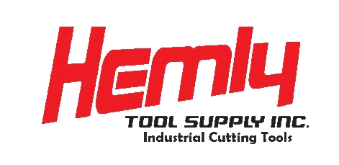

Scrap Carbide Recycling

Return Process

- Fill your own secure box with qualifying scrap carbide. (See Restrictions Below)

- Call Hemly Tool, 1-800-445-1068, to obtain a Recycle Return Authorization (RRA) number and a price per pound quote.

- Fill in the customer information and the RRA number in the customer information box on the back of this page and on the return label. This information will insure that you receive your check without delay.

- Put a copy of the form in each box you return.

- A check will be mailed to you 2-3 weeks from receipt of your shipment.

- If you have any questions about the shipment, call Hemly Tool at 1-800-445-1068. Please refer to the RRA# when calling.

We do not accept the following:

- Ceramic Inserts

- Cermet Inserts

- Diamond tipped inserts

- Tools that are not solid carbide (carbide cannot be connected or brazed to any other material)

- Carbide that was previously brazed

**Please do not include these items**
Recycling Form

Customer Information:

Make check payable to:

Company: ____________________________________________________________________________

Attention: ____________________________________________________________________________

Address: _____________________________________________________________________________

City, State, Zip: __________________________________ Phone: _______________________________

Have you used this service before? Yes _____ No ______

When ready to return:

Call Hemly Tool, 1-800-445-1068 to obtain and authorization number and per pound price quote.

Date:__________________ RRA#:_____________________(Box___ of ____ boxes)

Quoted per pound price: ___________ Estimated Weight: ______________ lbs.

Once you have completed this form, send your qualifying scrap carbide to:

Hemly Tool Supply
Attn: SCRAP CARBIDE
16600 Thompson Rd
Thompson, OH 44086

Scrap Carbide Recycling

